**TRANSACTION**

**CustomerInfo.cs**

**CustomerUtility.cs**

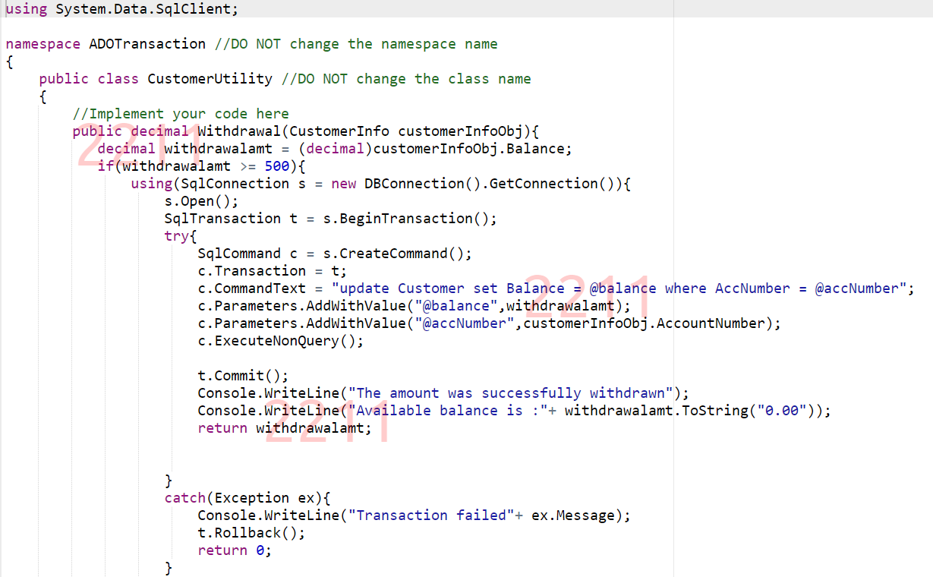

**Tasty Byte Beverages**

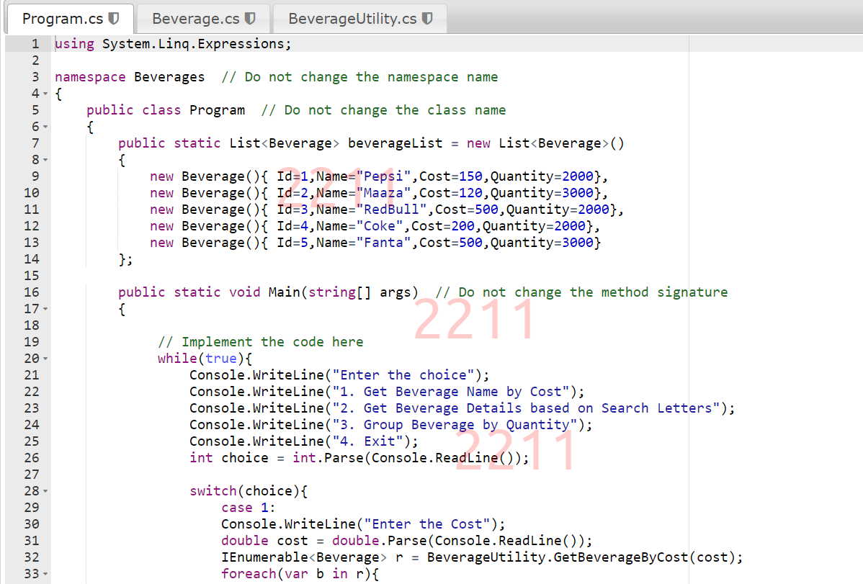

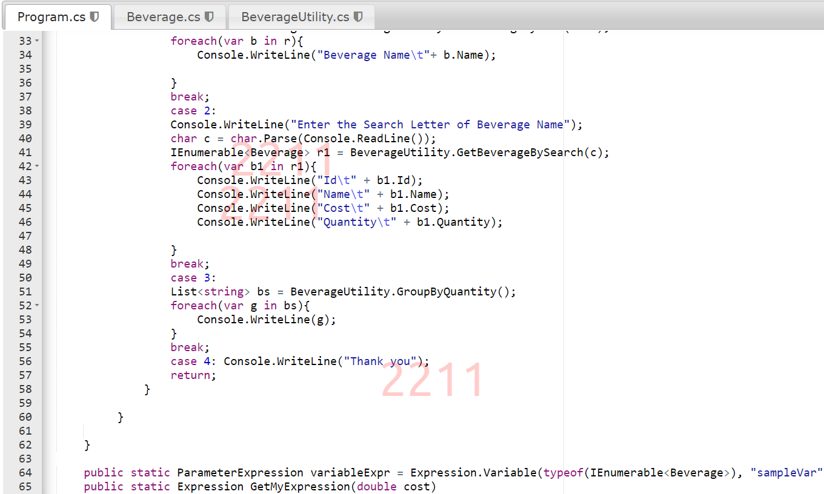

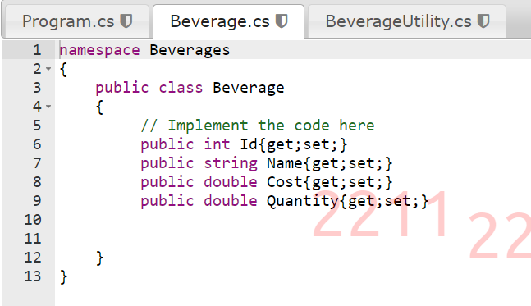

**Car Repository – Insert**

**Car Repository – Retrieve**

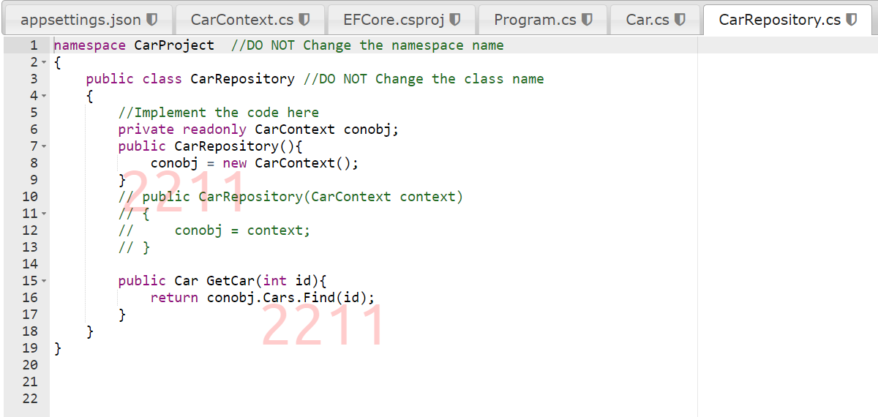

**Car Repository – Update**

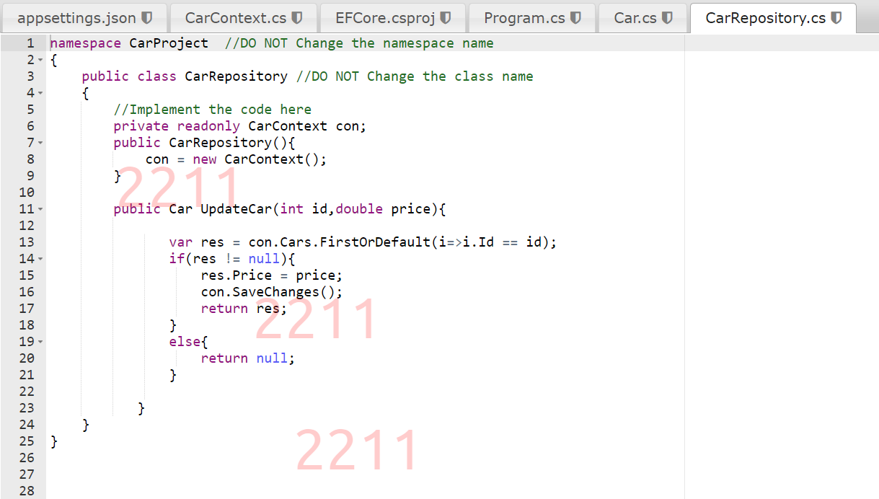

**Car Repository – Delete**

**Car Repository – Eager Loading**

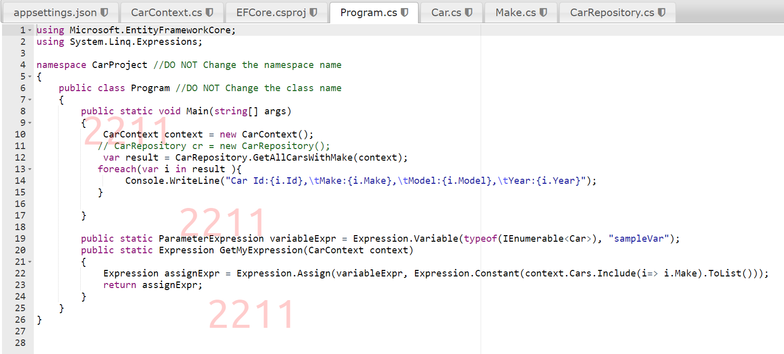

**Car Repository – Lazy Loading**

